Question 1

Question 2

Question 3

Question 4

Question 5

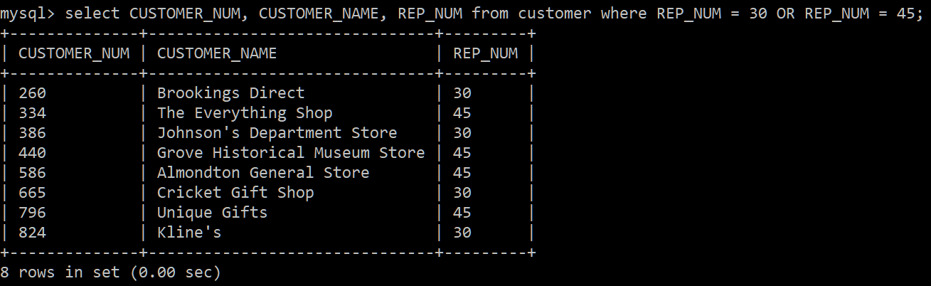

Question 6

Question 7

Question 8

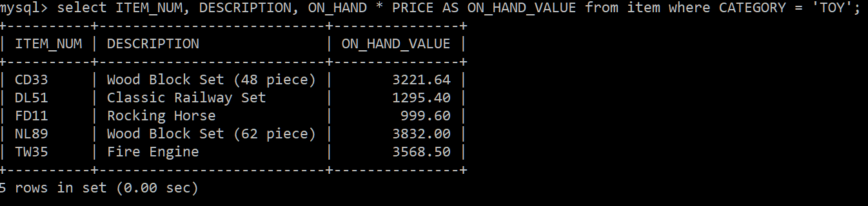

Question 9

Question 10

Question 11

Question 12

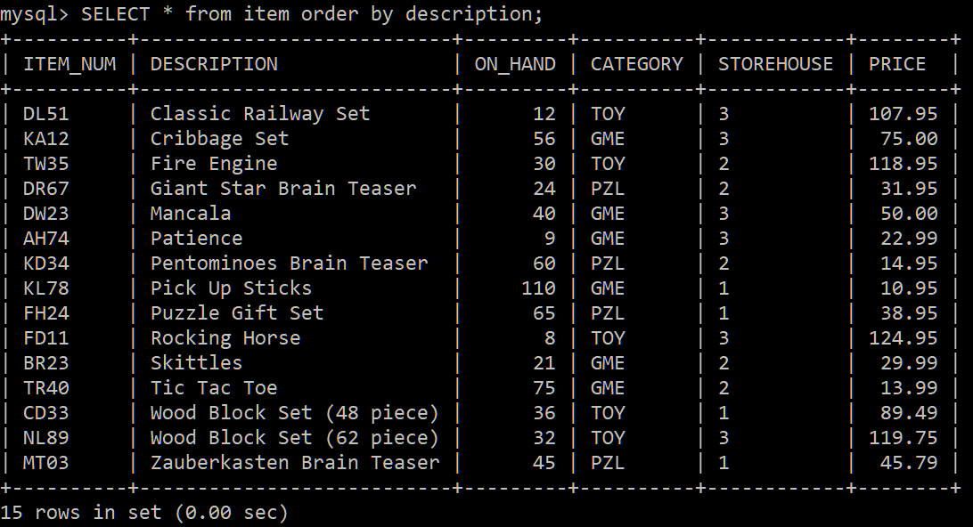

Question 13

Question 14

Question 15

Question 16

Question 17

Question 18

Question 19

Question 20

Question 21

